1. **Write a program to take command line input and check number is odd or even.**

import java.util.Scanner;

class even

{

public static void main(String args[])

{

int a;

Scanner s=new Scanner(System.in);

System.out.println("Enter any number:");

a=s.nextInt();

if(a%2==0)

System.out.println(a+" is Even Number.");

else

System.out.println(a+" is Odd Number.");

}

}

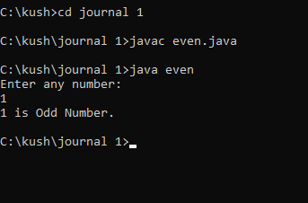

1. **Write a program to take command line input and sum of 2 number.**

import java.util.Scanner;

class sum

{

public static void main(String args[])

{

int a,b,c;

Scanner s=new Scanner(System.in);

System.out.println("Enter First number:");

a=s.nextInt();

System.out.println("Enter Secoend number:");

b=s.nextInt();

c=a+b;

System.out.println("The sum of 2 digit is:"+c);

}

}

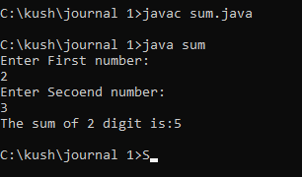

1. **Write a program to take command line input and calculate a Simple Interest**

import java.util.Scanner;

class simint

{

public static void main(String args[])

{

int p,r,n,a;

Scanner s=new Scanner(System.in);

System.out.println("Enter value of p :");

p=s.nextInt();

System.out.println("Enter value of r :");

r=s.nextInt();

System.out.println("Enter value of n :");

n=s.nextInt();

a=(p*r*n)/100;

System.out.println("The simpleinterest is:"+a);

}

}

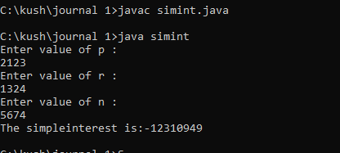

1. **Write a Program to take command line input and Check Number is Positive or Negative**

import java.util.Scanner;

class posneg

{

public static void main(String args[])

{

int a;

Scanner s=new Scanner(System.in);

System.out.println("Enter any number:");

a=s.nextInt();

if(a>0)

System.out.println(a+" is Positive Number.");

else

System.out.println(a+" is Nagative Number.");

}

}

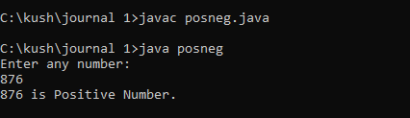

1. **Write a Program to take command line input and Check Year is Leap Year or Not**

import java.util.Scanner;

class leapyear

{

public static void main(String args[])

{

int a;

Scanner s=new Scanner(System.in);

System.out.println("Enter year:");

a=s.nextInt();

if(a%4==0)

System.out.println(a+" is Leap year.");

else

System.out.println(a+" is not Leap year.");

}

}

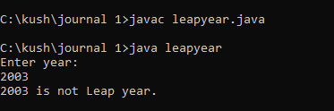

1. **Write a program to take command line input and find the character is vowel or Not.**

import java.util.Scanner;

class charvowel

{

public static void main(String args[])

{

char a;

Scanner s=new Scanner(System.in);

System.out.println("Enter any character:");

a=s.next().charAt(0);

if(a=='a'|| a=='e'|| a=='i'|| a=='o'|| a=='u'|| a=='A'|| a=='E'|| a=='I'|| a=='O'|| a=='U')

System.out.println("Enter character is Vowel.");

else

System.out.println("Enter character is Consonant");

}

}

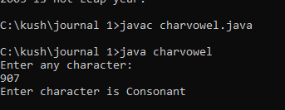

1. **Write a program to reverse a given number using while Loop.**

import java.util.Scanner;

class whilereverse

{

public static void main(String args[])

{

int a,r,temp=0,b;

Scanner s=new Scanner(System.in);

System.out.println("Enter any Number:");

a=s.nextInt();

b=a;

while(a>0)

{

r=a%10;

temp=temp*10+r;

a=a/10;

}

System.out.println("Reverse Number is " +temp);

}

}

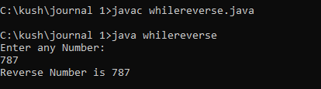

1. **Write a program to reverse a given number using For Loop.**

import java.util.Scanner;

class forreverse

{

public static void main(String args[])

{

int a,r,sum=0,b,i;

Scanner s=new Scanner(System.in);

System.out.println("Enter any Number:");

a=s.nextInt();

b=a;

for(i=0;a>0;i++)

{

r=a%10;

sum=sum*10+r;

a=a/10;

}

System.out.println("Reverse Number is " +sum);

}

}

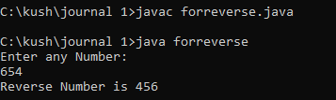

1. **Write a program to check Armstrong or not.**

import java.util.Scanner;

class armstrong

{

public static void main(String args[])

{

int a,r,sum=0,temp;

Scanner s=new Scanner(System.in);

System.out.println("Enter any number:");

a=s.nextInt();

temp=a;

while(a>0)

{

r=a%10;

sum=sum+r*r*r;

a=a/10;

}

if(temp==sum)

System.out.println(temp+" is Armstrong");

else

System.out.println(temp+" is not Armstrong");

}

}

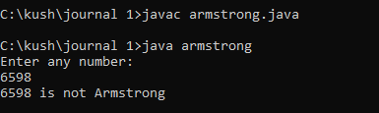

1. **Write to program check prime number or not.**

import java.util.Scanner;

class prime

{

public static void main(String args[])

{

int a,i,sum=0;

Scanner s=new Scanner(System.in);

System.out.println("Enter any number:");

a=s.nextInt();

for(i=2;i<a;i++)

{

if(a%i==0)

{

sum=1;

break;

}

}

if(sum==1)

System.out.println(a+" is not Prime Number");

else

System.out.println(a+" is Prime Number");

}

}

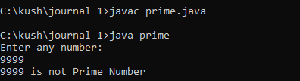

1. **Write a program to check number is palindrome or not.**

import java.util.Scanner;

class palindrome

{

public static void main(String args[])

{

int i,n,temp,sum=0;

Scanner S=new Scanner(System.in);

System.out.println("Enter any Number: ");

n=S.nextInt();

temp=n;

while(n>0)

{

i=n%10;

sum=(sum*10)+i;

n=n/10;

}

if(temp==sum)

System.out.println("Palindrome Number");

else

System.out.println("Not Palindrome Number");

}

}

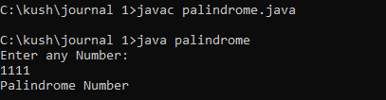

|  |
| --- |
| 1. **Star Pattern**   **\***  **\*\***  **\*\*\***  **\*\*\*\***  **\*\*\*\*\***  import java.util.Scanner;  class starpattern  {  public static void main(String args[])  {  int n,i,j;  Scanner s=new Scanner(System.in);  System.out.println("Enter number of rows you want to print:");  n=s.nextInt();  for(i=0;i<=n;i++)  {  for(j=1;j<=i;j++)  {  System.out.print("*");  }  System.out.println("");  }  }  } |
| 1. **Number Pattern Pyramid**   import java.util.Scanner;  class numberpattern  {  public static void main(String args[])  {  int r,i,j,counter=1;  Scanner s=new Scanner(System.in);  System.out.println("Enter any number:");  r=s.nextInt();  for(i=0;i<r;i++)  {  for(j = 0;j < r-i-1;j++)  {  System.out.print(" ");  }  for(int k = 0;k<=i;k++)  {  System.out.print(counter+" ");  counter++;  }  System.out.println();  }  }  } |
| 1. **ABCD Pattern Pyramid**   import java.util.Scanner;  class abcdpattern  {  public static void main(String args[])  {  int a,i,j=0;  char c;  Scanner s=new Scanner(System.in);  System.out.println("Enter any number:");  a=s.nextInt();  for(j=a;j>=1;j--)  {  c='A';  for(i=1;i<=j;i++)  {  System.out.print(c+" ");  c++;  }  System.out.println("\n");  }  }  } |

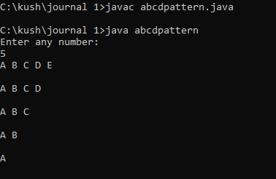

1. **Factorial Number Of Entered Number.**

import java.util.Scanner;

class factorial

{

public static void main(String args[])

{

int a,i,fact=1;

Scanner s=new Scanner(System.in);

System.out.println("Enter any number:");

a=s.nextInt();

for(i=1;i<=a;i++)

{

fact=fact*i;

}

System.out.println("Factorial of "+a+" is: "+fact);

}

}

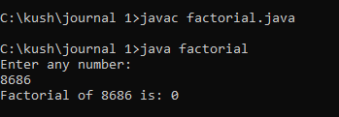

1. **Fibonacci Series Of Entered Number.**

import java.util.Scanner;

class fibonacci

{

public static void main(String args[])

{

int a,b=0,c=1,k,i;

Scanner s=new Scanner(System.in);

System.out.println("Enter any number:");

a=s.nextInt();

System.out.print(b+" "+c);

for(i=2;i<a;++i)

{

k=b+c;

System.out.print(" "+k);

b=c;

c=k;

}

}

}

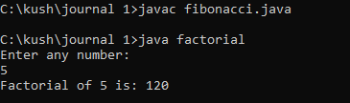

**Journal – 2**

1. **Bank Account Details**

import java.util.*;

public class BankAccount

{

private String depositorName;

private int accountNumber;

private String accountType;

private double balance;

// Constructor with no arguments

public BankAccount() {

this("", 0, "Savings", 0.0);

}

// Constructor with name and account number arguments

public BankAccount(String name, int accountNumber) {

this(name, accountNumber, "Savings", 0.0);

}

// Constructor with all arguments

public BankAccount(String name, int accountNumber, String accountType, double balance) {

this.depositorName = name;

this.accountNumber = accountNumber;

this.accountType = accountType;

this.balance = balance;

}

// Method to assign initial values

public void setInitialValues(String name, int accountNumber, String accountType, double balance) {

this.depositorName = name;

this.accountNumber = accountNumber;

this.accountType = accountType;

this.balance = balance;

}

// Method to deposit an amount

public void deposit(double amount) {

if(amount > 0) {

balance += amount;

System.out.println("Deposit successful. New balance is " + balance);

} else {

System.out.println("Invalid amount. Please enter a positive amount to deposit.");

}

}

// Method to withdraw an amount after checking balance

public void withdraw(double amount) {

if(amount <= 0) {

System.out.println("Invalid amount. Please enter a positive amount to withdraw.");

} else if(amount > balance) {

System.out.println("Insufficient balance. You can withdraw up to " + balance);

} else {

balance -= amount;

System.out.println("Withdrawal successful. New balance is " + balance);

}

}

// Method to display name and balance

public void display() {

System.out.println("Depositor name: \n" + depositorName);

System.out.println("Account number: \n" + accountNumber);

System.out.println("Account type: \n" + accountType);

System.out.println("Current balance: \n" + balance);

}

public static void main(String args[]){

Scanner s=new Scanner(System.in);

// Create an instance of BankAccount with no arguments

BankAccount account1 = new BankAccount();

// Set initial values using setInitialValues method

account1.setInitialValues("John Smith", 12345, "Savings",0.0);

// Deposit 500

System.out.println("Enter the amount That You want to Deposit:");

double depositAmount=s.nextDouble();

account1.deposit(depositAmount);

// Withdraw 200

System.out.println("Enter the amount That You want to Withdrawr:");

double withdrawAmount=s.nextDouble();

account1.withdraw(withdrawAmount);

// Display account information

}

}

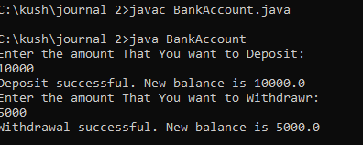

1. **Print Floyd’s triangle**

import java.util.*;

class Program2

{

public static void main(String[] args)

{

int n = 5;

int i, j, k = 1;

for (i = 1; i <= n; i++)

{

for (j = 1; j <= i; j++)

{

System.out.print(k + " ");

k++;

}

System.out.println();

}

}

}

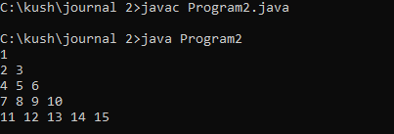

1. **Find Batsman’s and bowler’s Average**

class Crickter

{

public String name;

public double matchPlayed;

public void setValues(String name,double matchPlayed)

{

this.name=name;

this.matchPlayed=matchPlayed;

}

}

class Batsman extends Crickter

{

public double totalruns;

public double avarageRuns(double totalruns)

{

this.totalruns=totalruns;

return this.totalruns/matchPlayed;

}

}

class Bowler extends Crickter

{

public double wickets;

public double avarageWickets(double wickets)

{

this.wickets=wickets;

return this.wickets/matchPlayed;

}

}

class main

{

public static void main(String args[])

{

Batsman bm=new Batsman();

bm.setValues("Sachin Tendulkar",782);

double avgRuns=bm.avarageRuns(34357);

System.out.println("Batsman Information\n");

System.out.println("Batsman Name:"+bm.name);

System.out.println("Batsman Run:"+bm.totalruns);

System.out.println("Batsman Match Played:"+bm.matchPlayed);

System.out.println("Batsman Avg Runs:"+avgRuns);

Bowler br=new Bowler();

br.setValues("Muttiah Muralitharan",583);

double avgWickets=br.avarageWickets(1347);

System.out.println("\nBowler Information\n");

System.out.println("Bpwler Name:"+br.name);

System.out.println("Bpwler Wicketcs:"+br.wickets);

System.out.println("Bpwler Match Played:"+br.matchPlayed);

System.out.println("Bpwler Avg Wickets:"+avgWickets);

}

}

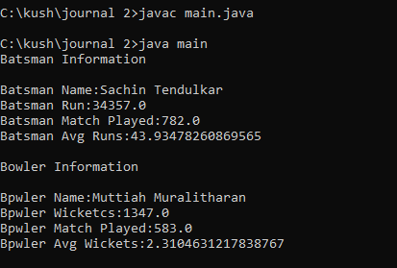

1. **Method overloaded**

class OverloadMethod

{

public void display(String s1,String s2)

{

System.out.println("The Concated String is:"+(s1+s2));

}

public void display(int a,int b)

{

System.out.println("The Addition of "+a+" and "+b+" is:"+(a+b));

}

public static void main(String args[])

{

OverloadMethod o=new OverloadMethod();

o.display("Kamlesh","Kumawat");

o.display(13,11);

}

}

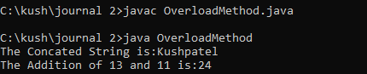

1. **Check string palindrome or not**

import java.util.*;

class Palindrome

{

public static void main(String args[])

{

String original, reverse = "";

Scanner in = new Scanner(System.in);

System.out.println("Enter a string to check if it is a palindrome");

original = in.nextLine();

int length = original.length();

for ( int i = length - 1; i >= 0; i-- )

reverse = reverse + original.charAt(i);

if (original.equals(reverse))

System.out.println("Entered is a palindrome.");

else

System.out.println("Entered isn't a palindrome.");

}

}

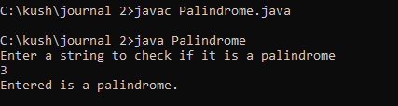

1. **String Sorting in alphabetic format**

import java.util.Arrays;

import java.util.Scanner;

public class SortingString

{

public static void main(String args[])

{

Scanner sc = new Scanner(System.in);

System.out.println("Enter a string value: ");

String str = sc.nextLine();

char charArray[] = str.toCharArray();

Arrays.sort(charArray);

System.out.println (new String(charArray));

}

}

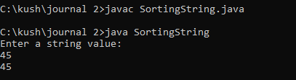

1. **Find Area**

interface Area{

public void Calculatearea();

}

class rectangle implements Area{

float x,y;

public rectangle(float x,float y){

this.x=x;

this.y=y;

}

public void Calculatearea(){

System.out.println("The Area of Rectangle is:"+(this.x*this.y));

}

}

class triangle implements Area{

float x,y;

public triangle(float x,float y){

this.x=x;

this.y=y;

}

public void Calculatearea(){

System.out.println("The Area of Triangle is:"+((this.x*this.y)/2));

}

}

class square implements Area{

float x;

public square(float x){

this.x=x;

}

public void Calculatearea(){

System.out.println("The Area of Square is:"+(this.x*this.x));

}

}

class CalculateArea{

public static void main(String args[]){

//hare hight=20 and width=40

rectangle re=new rectangle(20,40);

re.Calculatearea();

//hare base=20 and hight=40

triangle tr=new triangle(20,40);

tr.Calculatearea();

//hare hight=40

square sq=new square(40);

sq.Calculatearea();

}

}

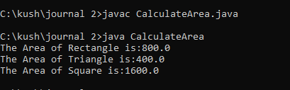

1. **Exception Handling**

class OddException extends Exception{

OddException(String str){

System.out.println(str);

}

}

class ExceptionHandaling{

public static void main(String args[]){

int a=Integer.parseInt(args[0]);

try{

if(a%2==0){

System.out.println("The "+a+" is Even.");

}

else{

throw new OddException("Number Consist Odd Value.");

}

}

catch(OddException e){

System.out.println(e);;

}

}

}

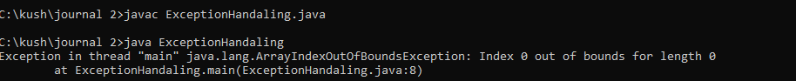

1. **Student Name and age in descending order**.

import java.util.*;

class StudentDetail{

public static void main(String args[])

{

String StdName[]={"Yash","Divyang","Kaushik","Ajay","Kamlesh","Shivraj","Abhay","Chetan","Vivek","Brijesh"};

int age[]={18,18,18,18,19,19,19,19,18,18};

int n=9;

String temp;

for (int i=0; i<=n;i++)

{

for (int j=i+1;j<=n;j++)

{

// to compare one string with other strings

if (StdName[i].compareTo(StdName[j]) > 0)

{

// swapping

temp = StdName[i];

StdName[i] = StdName[j];

StdName[j] = temp;

}

}

}

for(int i=0;i<=n;i++)

{

for(int j=i+1;j<=n;j++)

{

//to set the age in descnding order

int temp1;

if(age[i]>age[j])

{

temp1=age[i];

age[i]=age[j];

age[j]=temp1;

}

}

}

System.out.println("Names & Age in descnding order.");

System.out.println("Names\t\t\tAge");

System.out.println("==================== \t====================");

for (int i = n; i >=0; i--)

{

System.out.println(StdName[i]+"\t\t\t"+age[i]);

}

}

}

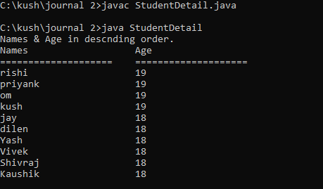

1. **All String function**

import java.util.*;

public class MyString {

private String str;

public MyString(String str) {

this.str = str;

}

public String reverse() {

return new StringBuilder(str).reverse().toString();

}

public String toTitleCase() {

StringBuilder result = new StringBuilder(str.length());

String[] words = str.split("\\s");

for (String word : words) {

if (!word.isEmpty()) {

result.append(Character.toUpperCase(word.charAt(0)));

result.append(word.substring(1).toLowerCase());

}

result.append(" ");

}

return result.toString().trim();

}

public String extractNFromRight(int n) {

if (n >= str.length()) {

return str;

}

return str.substring(str.length() - n);

}

public static void main(String[] args) {

Scanner scanner = new Scanner(System.in);

System.out.print("Enter a string: ");

String str = scanner.nextLine();

MyString myString = new MyString(str);

char ch;

do {

System.out.println();

System.out.println("Menu:");

System.out.println("1. Reverse string");

System.out.println("2. String in Titlecase");

System.out.println("3. Extract N-characters from right-end of the string");

System.out.println("4. Exit");

System.out.print("Enter your choice: ");

int choice = scanner.nextInt();

scanner.nextLine();

switch (choice) {

case 1:

System.out.println("Reversed string: " + myString.reverse());

break;

case 2:

System.out.println("Titlecased string: " + myString.toTitleCase());

break;

case 3:

System.out.print("Enter N: ");

int n = scanner.nextInt();

scanner.nextLine();

System.out.println("Extracted " + n + " characters from right: " + myString.extractNFromRight(n));

break;

case 4:

System.out.println("Exiting...");

System.exit(0);

break;

default:

System.out.println("Invalid choice. Try again.");

}

System.out.println("Do you want to continue?(press=y)");

ch=scanner.next().charAt(0);

}while(ch=='y');

}

}

